SeekcyBeacon SDK for iOS 集成指南

Seekcy官网上，有SeekcyBeacon相关的所有指南、API、教程等全部文档。本文档的更新版本，都会及时发布到该网站上。

* 产品功能说明

目前我们的iOS SDK 主要提供以下功能

1. 扫描周围的SeekcyBeacon
2. 连接、配置SeekcyBeacon
3. 区域监听SeekcyBeacon：进入、离开

* SDK集成

1. 导入 SeekcyBeaconSDK.framework

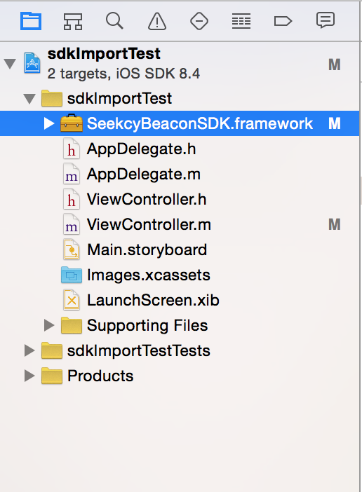

2． 把 SeekcyBeaconSDK.framework 同时添加到 ‘Embedded Binaries’ 中

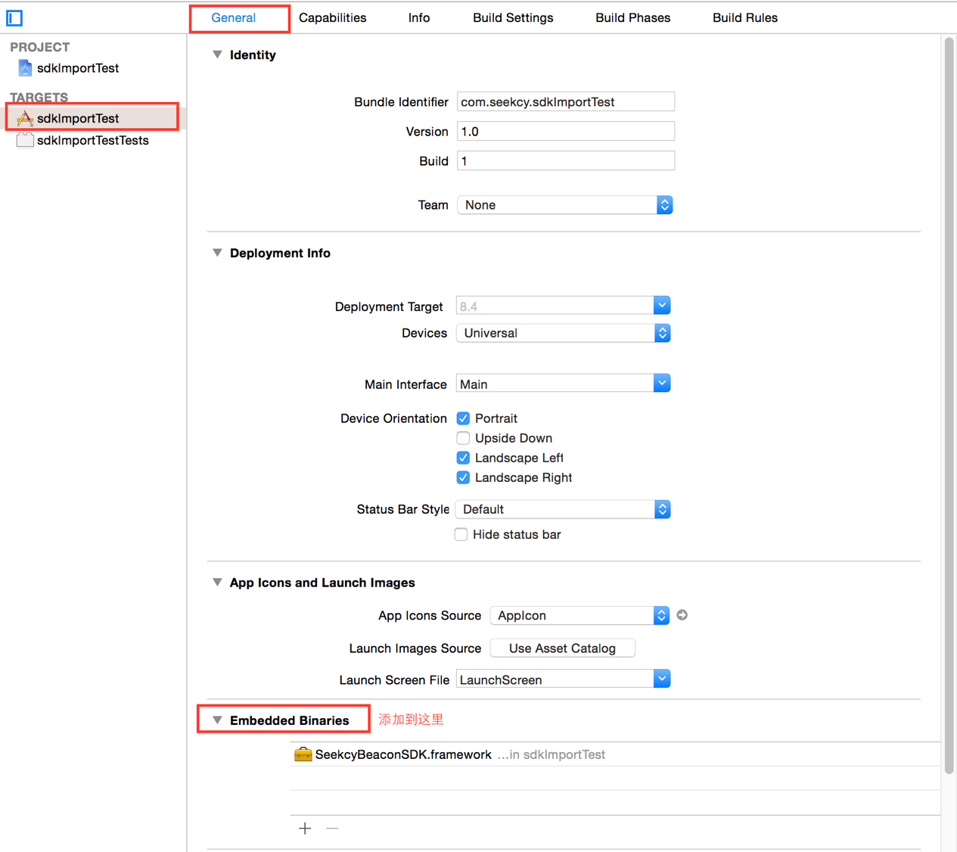

* 示例代码

@import SeekcyBeaconSDK;

1. 扫描

（1） SeekcyBeacon防蹭用

// 设置防蹭用解密密钥

[SKYBeaconManager sharedDefaults].seekcyDecryptKey = @"A5B5C146ADA7291E7FF5579539C04181B2E3F58C232641D741D03EED5932409D";

注意：

请在SDK启动前设置；防蹭用密钥必须为32bytes长度的十六进制String类型，密钥由Seekcy提供，并且配合支持防蹭用的SeekcyBeacon使用

（2）扫描

@interface ViewController ()<SKYBeaconManagerScanDelegate>

- (void)viewDidAppear:(BOOL)animated{

[super viewDidAppear:YES];

// 扫描

NSArray \*scanUUIDArray = @[[[SKYBeaconScan alloc] initWithuuid:@"E2C56DB5-DFFB-48D2-B060-D0F5A71096E0" name:@"apple"],[[SKYBeaconScan alloc] initWithuuid:@"FDA50693-A4E2-4FB1-AFCF-C6EB07647825" name:@"寻息摇一摇"],[[SKYBeaconScan alloc] initWithuuid:@"C91ABDBE-DF54-4501-A3AA-D7BDF1FD2E1D" name:@"aaaaa"]];

[[SKYBeaconManager sharedDefaults] startScanForSKYBeaconWithDelegate:self uuids:scanUUIDArray distinctionMutipleID:YES];

}

delegate返回结果

全部Beacon，（单id，多id beaon一起返回）:

// 返回全部 beacon

- (void)skyBeaconManagerCompletionScanWithBeacons:(NSArray \*)beascons error:(SKYBeaconManagerError \*)error{

// do sth...

}

单id， 多id 分开返回:

// 返回单id beacon

- (void)skyBeaconManagerCompletionScanWithSingleIDBeacons:(NSArray \*)beascons error:(SKYBeaconManagerError \*)error{

if(!error){

[self.beaconScanedArraySingleID removeAllObjects];

[self.beaconScanedArraySingleID addObjectsFromArray:beascons];

[self.myTableView reloadData];

}

else{

// do sth...

}

}

// 返回多id beacon

- (void)skyBeaconManagerCompletionScanWithMutipleIDBeacons:(NSArray \*)beascons error:(SKYBeaconManagerError \*)error{

if(!error){

[self.beaconScanedArrayMutipleID removeAllObjects];

[self.beaconScanedArrayMutipleID addObjectsFromArray:beascons];

[self.myTableView reloadData];

}

else{

// do sth...

}

}

1. 连接

[[SKYBeaconManager sharedDefaults] connectBeacon:self.detailBeacon completion:^(BOOL complete, NSError \*error) {

[activityView stopAnimating];

if(complete){

// 连接成功

}

else{

// 连接失败

}

}];

1. 取消连接

[[SKYBeaconManager sharedDefaults] cancelBeaconConnection:self.detailBeacon completion:^(BOOL complete, NSError \*error) {

if(complete){

// 取消连接成功

}

else{

// 取消连接失败

}

}];

1. 配置(单id)

[[SKYBeaconManager sharedDefaults] writeSingleIDBeaconValues:beaconToConfig completion:^(NSError \*error) {

// 配置时的错误

if(error != nil){

}

// 配置成功

else{

}

}];

1. 配置(多id)

[[SKYBeaconManager sharedDefaults] writeMutipleIDBeaconValues:beaconToConfig completion:^(NSError \*error) {

// 配置时的错误

if(error != nil){

}

// 配置成功

else{

}

}];

1. 区域监听

@interface MonitorViewController ()<SKYBeaconManagerMonitorDelegate>

self.monitorBeacons = @[[[SKYBeaconRegion alloc] initWithProximityUUID:[[NSUUID alloc] initWithUUIDString:@"E2C56DB5-DFFB-48D2-B060-D0F5A71096E0"] identifier:@"苹果默认"],

[[SKYBeaconRegion alloc] initWithProximityUUID:[[NSUUID alloc] initWithUUIDString:@"FDA50693-A4E2-4FB1-AFCF-C6EB07647825"] identifier:@"苹果默认"]];

// 监听

[[SKYBeaconManager sharedDefaults] startMonitoringForSKYBeaconRegions:self.monitorBeacons delegate:self];

delegate返回进出入区域：

// 进

- (void)skyBeaconManagerDidEnterRegion:(CLRegion \*)region{

}

// 出

- (void)skyBeaconManagerDidExitRegion:(CLRegion \*)region{

}

1. Ranging

@interface RangingViewController ()<SKYBeaconManagerRangingDelegate >

self.rangingBeacons = @[[[SKYBeaconRegion alloc] initWithProximityUUID:[[NSUUID alloc] initWithUUIDString:@"E2C56DB5-DFFB-48D2-B060-D0F5A71096E0"] identifier:@"苹果默认"],

[[SKYBeaconRegion alloc] initWithProximityUUID:[[NSUUID alloc] initWithUUIDString:@"FDA50693-A4E2-4FB1-AFCF-C6EB07647825"] identifier:@"苹果默认1"]];

[[SKYBeaconManager sharedDefaults] startRangingSKYBeaconsInRegions:self.rangingBeacons

delegate:self];

delegate返回结果

#pragma mark - SKYBeaconManagerRangingDelegate

- (void)skyBeaconManagerDidRangeBeacons:(NSArray \*)beacons inRegion:(SKYBeaconRegion \*)region{

}